Title of paper: Curricula 3D Visualisation: a Tool of Education Quality Assessment in The School of Public Administration

Authors: Alexey Barabashev; Sergey Efremov (School of Public Administration, National Research University - Higher School of Economics, Moscow, Russia)

Generally, a curriculum represents a list or a sequence of courses to be covered during an educational process. Each course in the curriculum should have its own syllabus, including a concise program of the course, outlining its most important characteristics, such as teaching hours, subjects covered, learning outcomes, assesment methodology, course structure, course goals and description, related literature, course requirements, schedule, content and general policies information. Teachers separately elaborate syllabi which would then constitute the curriculum of a program, while students choose among syllabi to frame their own educational course in the curriculum. At the same time, the curriculum can be referred to by students and teachers to decide either on the positioning of any particular course syllabi within the overall structure or to define one’s individual educational direction.
A typical course syllabus in the School of Public Administration at the Higher School of Economics (further referred to as SPA and HSE, respectively) would include: course plan and description, hours, literature, course goals and content, schedule. A typical curriculum would include a list of subjects, credits, evaluation forms, duration (in weeks and hours) and distribution of workload by module (see: Picture 1).

It is a bulky table structure which is used to find potentially the most interesting courses and read their syllabi. This serves different goals: to make a student's choice of discipline more informed and avoid excessive informational asymmetry, to make the instructor's expectations clearer and just give a vision of what one would learn.This structure and curriculum-syllabi relation have their evident time-proven intrinsic advantages mentioned above which are always necessary to make teacher-student communication more "informed", eliminating unnecessary asymmetry of visions between the teacher (considered agent) and student (considered principal). Thus, curricula and syllabi normally have informative, content value.
However, there is still no system or mechanism which could allow for syllabi and cullicula of different educational programs comparison or which could show real links between syllabi in one program or between courses in different programs. There is evidence, that computer technologies, so called information and communication technologies as well as modern LMS systems are significantly changing the academic world. As applied to curricula, for example, several papers provide mathematic tools for comparing curricula and connecting them into the sole structure. So-called, correspondence analysis, data and text mining are based on the text information analysis of syllabi. Ida Massaki conducted research considering sensitivity for correspondence analysis and curriculum analysis. He explored the way of grasping the global characteristics of curricula to then visually represent them. This task was performed through correspondence textual analysis between the rows and columns of different syllabi containing comparable information. Ida stated that a global perception of curricula can bring about new knowledge discovery. His work focused mainly on the mathematical potential of such an analysis.
Another important use of ICT was found by Taiwanese researcher Su, who based his visualization ideas on knowledge mapping and construction analysis of education assessments. He suggested a novel way of educational assessment through his system called KMAAS. Based on analyzing course material and course concepts the system attributed concept-weight parameters and visualized the relationships among concepts. An important application to his work was the ability to cross-refer between concepts in different disciplines thus allowing the compilation of teaching assessments with high precision. The growth of satisfaction among teachers revealed by the survey demonstrated the system’s potential. However, both systems are primarily focused on achieving research purposes, and cannot be used for clear and every-day usage by students and teachers.

The authors of this paper tried to go further in these rare but nevertheless important investigations and integrated the assumptions of the two models, enriching them with new ideas. We try to simplify the visual model of educational curricula.
In the first part of this paper we explain why visualizing, systematizing and comparing curricula could be used to construct new curriculum representation models, and what the implications of systematization for different university stakeholders, ranging from university top-management to alumni to entrants are. In the second part, we will explain in detail the novel way of 3D visualization of the curricula and technical steps for setting its parameters. We will then move on to discussing the potential outcomes and best uses of the new visualization system explored.

Identifying the problem: curricula visualization requirements

With the advantages already being evident, any current form of curriculum visual representation has an important drawback - it does not allow for fast and generalizing comparisons between syllabi, and courses without using sophisticated software and mathematic models. Reading syllabi is definitely the most reliable way of getting primary information about the course. If one wants to see all the courses, deductively, an educational program could be presented in a table or in a list featuring the most common course names, hours, credits attributed, and majors. However, what should one do if he then wants to know what the actual relationship between disciplines is, what the competencies and skills acquired through those disciplines are and how they interrelate if at all, which departments provide courses. The most evident existing way is to study all the syllabi simultaniously in the frame of the program curriculum, and to try and find links between courses’ content. Another way is to pass four years of Bachelor's or two years of Master's program, and come to your own conclusions. However, in this case you would never know how the electives you have not chosen fit into the overall educational program and what you miss when choosing this subject and not another subject. This “opportunity cost” includes unnecessary knowledge dispersion and inability to build on skills acquired during the courses already followed by the student and cumulatively to multiply one’s skills as a professional. This is most important if the student chooses courses functionally to apply his future work aspirations or research interests. However, facilitating the correct choice by students is not the only virtue of systematizing the curriculum. We will later cite some of the university stakeholders which can benefit from seeing the curriculum in its global integral form.

University entrants and their parents
When a university entrant chooses his Bachelor's degree, his choice is dictated by a set of subjective and objective reasons. Omitting the first group which would include individual perceptions, family expectations, psychological patterns and others, which represent more an issue for social and psychological sciences, we move on to objective criteria. In the case, where an entrant does not have access to internal trust-worthy information about any program of studies, he would need quantifiable or ranged criteria upon which to base his choice . One of the criteria is intellectual, personal disposition to, and talent inclination in a certain area: social sciences, natural sciences, human sciences, engineering sciences, and others. This could be further classified into economics, mathematics, politics, sociology, law, and other general branches. If one wants to earn a BSc in Public Administration and has a good educational track in high school, he should then consider a range of universities which provide such programs. Programs might have different names, different curricula, majors, sets of disciplines. On the other hand, there may be similarities, such similar names of courses. Broadly speaking, to choose his first best Bachelor's program even if the entrant is sure of his willingness to proceed with the area of public administration, he would need to compare slightly between 90 disciplines and much more electives between different universities. Studying and comparing syllabi might be feasible if the entrant is choosing between two universities, but the greater the number of programs considered, the harder it is to make the right choice. Thus, the entrant would need more generalized, systematized criteria upon which he can base his decision. One of the criteria could be a relative content presence of social, law, economic and mathematic disciplines in the overall program. All of these scientific fields are always present in any BSc in Public Administration - especially in the core basic disciplines. However, their relative ratio between the programs might be different - one program may contain more social sciences and another program might contain more of economics. Based on individual preferences, the entrant having such information would be able to make his choice more balanced.

Students
Students base their choice of major and their choice of electives either on previous experience of the school's sophomores and juniors or by studying and comparing syllabi. Again, the guiding criteria among others are: personal inclinations and talents, expected learning outcomes, estimated value for the aspired job, skills to be acquired. A typical "goals" section would include information about skills and learning outcomes. However, such a syllabus would rarely refer to required skills, meaning pre-requisite skills necessary to follow the course. A student who has a strong motivation and a clear vision of his future, can nevertheless, find it difficult to understand which of the disciplines best fit his needs. Providing him with information about the pre-requisite disciplines and the disciplines of the considered subject is itself a pre-requisite to - give a clearer vision of where the subject fits into the educational system. Thus, a motivated student aiming to work in a particular field, keeping in mind his potential employer's requirements would be able to build his own educational tracks - based on the system of pre-requisite disciplines for each subject. Seeing pre-requisite "spiders" is like seeing forward and backward citations which allow the right placement of the discipline into the overall system.

International students and exchange students
International double degree-rewarding programs or simple exchange programs is a wide-spread phenomenon in the academic world. However, an exchange student would always try to tailor his program to his individual needs. Balancing between individual needs and program (especially, degree-earning) requirements would make it necessary to build an individual plan of studies each time. Comparing between universities on the national level can be sometimes an easy process, especially where educational standards are strict and common for everyone, in which is the case in Russia. However, comparing between national systems may reveal many cross-validation problems. Subjects should be compared according to some formal criteria, and should not overlap in content. This is a difficult task which cannot be fully solved by systematizing the curricula but which is resolved in some way if the parties and students know what the potential links between the programs, their similarities and differences are. Having such information is crucial to an international student when choosing the right program and the right set of courses.

School Scientific and Administrative Council
Whatever the name of the governing decision making body of the school which makes decisions regarding the education process, oversees its quality and makes sure to deliver best education to the students, the advantages of presenting the curriculum as an integral system for this group are of utmost importance. Based on the system of pre-requisites and relative presence of different disciplinary fields the faculty staff can estimate the overall efficiency and quality of the educational process within any chosen program (MSc, BSc) according a criteria based on prerequisites. If the courses are interlinked and the connections are displayed, the school's staff can estimate the level of integrity of the educational process, identify outliers and less connected courses, identify the most common educational tracks and how subjects fit into the system. It is easy to avoid the duplication of course content, if the links between courses are clearly identifiable. It is also important that, the school's management should have a tool to understand if the courses are taught in the right sequence - and then move their corresponding timing within the same year of studies or between different years. This should be done to respect the correct sequence of teaching disciplines. Otherwise, students could have to follow some of the subjects with their inferiors or superiors if a course is taught in a wrong sequence and cannot be moved. Finally, the school's administration could have an approximate but nevertheless qualitatively justified reason to say that one program is better than another - even in different areas - judging from the percentage of disciplines taught in a wrong order. Certainly, this is an important but not exclusive method to estimate the overall quality and efficiency of the program as a whole and thus bench-mark and compare with other programs.

Employer
If not mentioned or stated otherwise, the employer will consider first the university and the school that the job candidate graduated from. During the next step, the employer can study the official transcript, which normally features the subjects followed and marks received for each. No detailed understanding by the employer of skills and competencies that the candidate might have can be guaranteed. In this case, the employer would either trust the university, the program or his previous experience. Systematizing curricula basing on the pre-requisite feature of each discipline would allow a better understanding of the educational directions of graduates. Educational directions can also be judged by their soundness if they are built from interrelated disciplines and are connected in a logical chain. These chains can then be matched to sets of competencies, which is easier than considering each course target skills and competencies.

3D-iCurricula system design

The proposed mechanism of curriculum integration between its courses is based on the principle of pre-requisite disciplines. As all courses are a part of the same program and are said to lead to a sole and same degree, we expect that they all have a relation to the abilities which graduates earning this degree should dispose of. Inductively, we suggest that there is a certain deeper than nominative (by name) relation between the courses. Thus, we suggest that courses relate to each other by their content. Several methods have been suggested by computer science experts including mathematic modeling, correspondence analysis, cross-reference analysis and text mining to define what the possible relations between disciplines are. However, this research needs to be broadened as content analysis cannot reflect all the nuances of a particular course or discipline. Whereas, disciplines are inter-related this means that some of them are pre-requisite to others and at the same time they have their own pre-requisites - these relations should be thus explained in more detail by instructors. We then looked at the current form of curriculum representation - including syllabi. This form is highly informative with respect to any separate subject but is of little use to see how subjects relate to each other. Even a nominative way of analysis is not efficient as disciplines are sometimes strongly heterogeneous. The only logical classifier allowing the grouping disciplines in order to have an overall picture of the educational program is domain-related and specialization-related (e.g., core disciplines, human sciences, natural sciences, major-related disciplines).
In a new classification system we suggest to break up all the disciplines into two general groups: basic disciplines and derivative disciplines, or courses. Basic disciplines are core disciplines which are necessary and fundamental to teaching other disciplines listed in the curriculum. For example, "law" and "econometrics" are necessary in a "Public policy analysis" class, and thus they should precede it on the education timeline. Derivative disciplines are those built upon basic disciplines, which exist on the edge of other disciplines or use some of the knowledge of those disciplines. Thus, some of the disciplines can be both basic and derivative if they have subjects both following and preceding.
In this classification basic disciplines are further divided into perfectly basic if they have no preceding disciplines in the program, and closing disciplines which do not have any forward relations. Perfectly basic and closing disciplines will then be referred to as frame disciplines. If the course has neither forward nor backward connections it would be referred to as independent discipline.
For example, English language, economic theory, macro- and microeconomics, philosophy, sociology, psychology, culture, history of governance, linear algebra and mathematic analysis, management and economic statistics are said to be perfectly basic in the School of Public Administration in the HSE curriculum. These disciplines may be classified by branches - human, social and economic sciences, mathematics and natural sciences, profession-related subjects (management, economic statistics, history of governance).

Picture 1. General overview of the SPA at HSE curriculum old representation form:

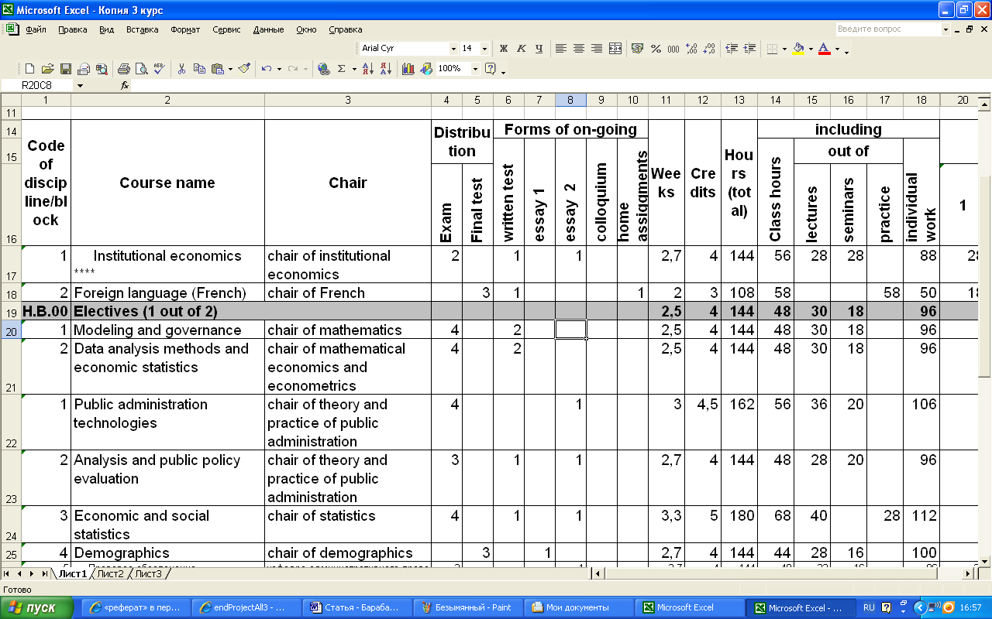
Estimating the pre-requisite links of each subject would give a clearer idea of the following information:
- if the disciplines are taught in the right sequence
- if practice work is actually related to course work
- if the ratio of different disciplines is appropriate for the chosen specialization
- what is the relative weight of each subject (according to the number of forward links) and its level integration into the overall framework (high density of links, medium density, independent)
- to identify independent disciplines and analyze why they are independent and what is their role in the overall education process
- what are the closing disciplines and hence what are the major competences they are supposed to close upon
- what is the content of derivative disciplines (by their backward connections)
- are core disciplines really core and which of the perfectly basic disciplines are actually more important and least important for the overall programme completion and hence should be attributed less or more credits or time.

In order to classify and rank disciplines in their relations several methods could be used:
- by school (philosophy, economics, management, sociology, etc.)
- by major
- by surveying the teaching staff and asking them to identify pre-requisites to their discipline courses (in the list of all the subjects taught in the programme but given in the alphabetic order to avoid bias).

The most accurate results are achieved through surveying as professors only know the names of the courses without any supplementary information (school, year of studies, duration, instructor, etc).

As a result we are supposed to have more precise information on the positioning of any particular discipline in the program structure. For example, general sociology might contain philosophy, administrative theory and mathematic methods. Economic and social statistics might contain linear algebra, mathematic methods and economics. Thus, to study general sociology the student should know the fundamentals of philosophy, should distinguish between different concepts of social structure and its functioning. Secondly, that student should be familiar with the basic administrative principles, and finally, should know the way of analyzing and working with quantifiable data sets. This basic to general sociology courses might further include English (to be able to work with international literature), statistics and others. This division is conditional and is based on nominative principle without expert insight. An instructor matching the courses could provide better and more a reliable level of precision (especially if given short course annotations).
This quality of derivativeness of a discipline, however, does not mean that general sociology strictly equals the sum of philosophy, administrative theory and mathematical methods, and it does not exclude specific to the course unique information which can be present to a greater or lesser extent. The system of prerequisites cannot show this extent and hence, cannot be used as an accurate tool for setting credits attributed to every course, though prerequisites give us a vision of the positioning of each course within the system and thus of the overall integrity of the programme. Further, implications of this system include using it for other systematizations, to cite only among others, ability-related classification we have already mentioned.

Surveying and fine-tuning
Going from an axiomatic assumption that each derivative discipline contains some basic disciplines and a percentage of its unique course-related knowledge, we can adjust the structure of the survey. At the School of Public Administration at HSE we asked every teacher to list the courses which the students should follow before following his course.
Three ways of surveying, hence are possible:
- to ask the instructor to identify courses basic to his discipline and range them by priority
- to ask the instructor to fill in the disciplines he deems to be important, combining multiple-choice question with its open part.
- to ask the instructor to write down all the disciplines, which he feels are important to his course.

Based on the aims of such a survey: to estimate the integrity of the existing system and to estimate the integrity and the adequacy of courses or just the adequacy of the courses taught, the researcher should choose respectively from these three methods. In the first case, only the prerequisites of each discipline are evaluated. In the second case, the results might be more heterogeneous as professors might include their own courses, and name differently the same course. In the latter case, the results will be most heterogeneous and least applicable as they may fully deviate from the actual courses’ framework and professors might additionally forget the courses which they otherwise would have mentioned, should they see the list.

The question of priority is important as it allows us to estimate the relative ratio and importance of basic disciplines in any derivative discipline. It would not allow judgement of the originality of the course, and to range basic disciplines in order of their relative importance to that particular discipline.
In order to estimate the relative importance of each composing element of a derivative discipline, we can introduce the concept of scientific field-related capacity of each discipline. Thus, if we define through the survey the list of basic to the program disciplines, we can then attribute absolute field-related capacitive characteristic to them (eg, pure economics will have 100% economic capacity, law will have 100% law capacity, etc.).
As a result, when all instructors answer the survey, we would have many educational directions, where the thickness of connection lines would represent the relative importance of any particular discipline to this subject, while capacity histograms for each subject would demonstrate the relative presence of each basic discipline in the current subject, though definitely not providing information on the level of original material present in this subject.

Visualizing
To make the system easy-to-handle, easy-to-analyze and easy-to-compare, it is necessary to represent it on one screen without the necessity to scroll left and right, up and down. The most visually and logically acceptable form of positioning the text is in a circle as a circle would not allow the argument that any one discipline is prior of inferior to another, otherwise known as the round-table principle. Then by adding on years and modules of education we adjust the third dimension which makes our system look like a cylinder. The cylinder is made pivoting so that any user can easily access any piece of information displayed on it (please see Picture 2 for the screenshot of the current 3D-iCurriculum of SPA at HSE).

Picture 2. 3D-iCurriculum of SPA at HSE screenshot
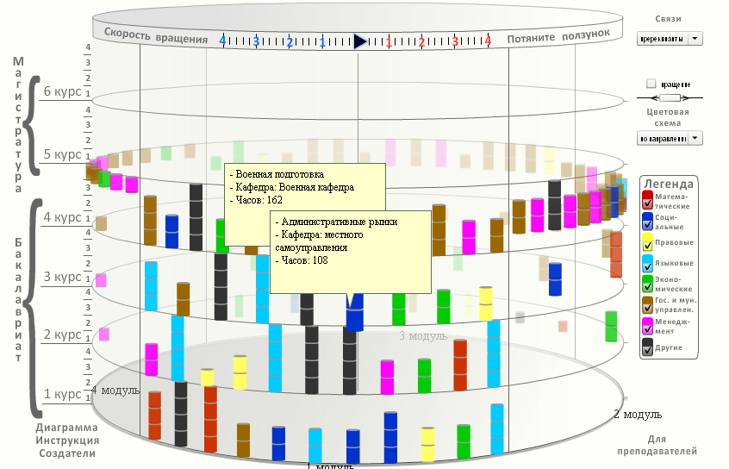

On this pivoting 3D cylinder on the y-axes we mark years divided by horizontal cross-sections (thus, first go 3 or 4 years of Bachelor's and then 1 or 2 years of Master's). Years in their turn are divided into modules (4 modules per year) - marked also by horizontal faded cross-sections. The lower plane of the cylinder is also cut into 4 sectors which also represent 4 modules. Each course is represented in the form of a small cylinder (we will refer further to this as “keg” to avoid confusion) which is positioned on the 3D cylinder according to the timing of teaching (timeline).
Each keg appears in the system as the instructor defines the year and the module when it is being taught. Each keg is separately processed in the system and thus may be attributed any set of meta-data which can then be represented on the screen. For example, kegs could be attributed different colours to signify different majors which the kegs correspond to, or to distinguish between core disciplines and major disciplines. Otherwise, colours of kegs could represent the scientific profile of the discipline (eg, language, economics, law, public administration, social, mathematical, managerial, and others - for a BSc in public administration).
Courses can be classified also by status (core-obligatory and optional).
In order to make all sorts of applications possible, we introduce a classification drop-down box into the visual form of curriculum representation and make the system scalable for adding on supplementary options into the instructor's questionnaire. Thus, future users of this system would be able to optionally introduce only that information from curricula and syllabi which are only necessary for them and make classifications by parameters they need (using colours’ and sizes of kegs’ variability in visual representation).

Prerequisites which are based on this questionnaire are shown when clicking on any particular keg on the cylinder. By clicking once, the system would by default show all backward and forward connections of the first level. The user can then set in another drop-down box the number of forward and backward levels of connections to be displayed as well as see all the connections this subject is present in. The system would automatically colour connections with pre-requisite courses (kegs) in red if they are taught in an incorrect sequence. This means that some subject is pre-requisite to the one considered but is taught after it on the educational timeline (see Picture 3).
When double clicking on the course, the user would have a window of the course, giving the instructor's photograph, the name of the course and a link to the course's syllabus for more detailed and in-depth information. This window can also feature the number of credits, hours, chair's name, capacity characteristics and other user-set information.

Picture 3. Screenshot of 3D-iCurriculum of SPA at HSE showing prerequisites to a chosen course

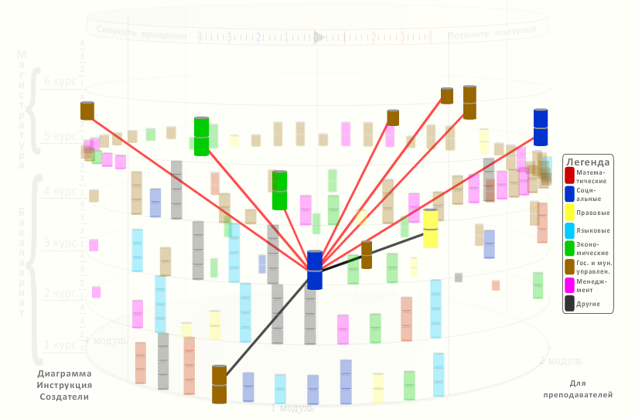

Best uses

The proposed visualization system is not supposed to alter any part of the curriculum or to distort its content in any way. However, it allows us to systamatize information present in syllabi for each course according to a user-set criterion. The number of such criteria is pre-defined by the system's administrator. For that purpose the system is made scalable to use additional features.
Further we list the best uses for this system with concise annotations.

Seeing educational chains
Students would be able to construct their educational chains based on abilities, personal expectations and inclinations as connections provide more accurate information on the positioning and hence the possible content of each subject. Employers are able to evaluate the integrity of the system. If one includes abilities into the system each subject is able to form, then the employer would be able to see what the competencies formed in relevant chains actually are. Also students would make a more informed choice of their programs, subjects and majors.
Moreover, the system allows for on-line course selection, this means that students will be able to choose subjects on-line and see their previous and advised future educational tracks: so that the teaching department would automatically receive all the relevant information on course popularity. This element of the system becomes more important as the number of electives increases.

Connecting Bachelor's and Master's
In Having a cylinder for each program we have a tool to cut the upper part of the cylinder and see what the connections are between disciplines in Master's and Bachelor's in-between programmes, if any. This is important if the student changes the university but not the field of study.

Juxtaposing programs
In placing two of such cylinders on the same screen side-by-side and making them turn, we will be able to visually easily compare, depending upon the criteria set in the drop-down boxes, the overall education process in-between programs of the same university, in-between majors of the same program, in-between programs of different universities. This is highly useful for entrants and for school’s administration to see how their curriculum logically relates to curricula of other universities.

Creating individual study plans
Some of the students pursue their courses by getting company financing. If the company wants an individual education plan, it can then depict the necessary subjects and mark them on the cylinder, thus kegs could be juxtaposed making the creation of an individual plan of studies easier.

Exchange programs
Many of the exchange programs are institutionalized and are based on mutual course recognition. Juxtaposing the Master's or Bachelor's parts of cylinders for programmes of two or more different universities could help to drive comparisons, create individual study plans and establish equivalences between the programs and courses.

Scalability
The proposed system can easily represent more information we have not yet mentioned. For example, the system could be presented as a 2D plane. This means that the same information would be unwrapped and put on a plane surface. That would make it easier to compare programs if one can drag one education plan and drop it on the other education plan plane. The system would automatically count discrepancies, similarities and logic connections (through content related analysis).
Also the window with the course information could feature a link to acquired competencies and that links would be functional to prerequisite data.
Another possible option is to introduce information on drop-out rates, attendance rates and course popularity for each keg. That is simple as such statistics are already present in any teaching and curriculum department. Such information whilst not being secret can reveal interesting results when being put on the same screen for the whole of the courses present in the programme and compared to other programs.
Another possibility is to make kegs thicker if they have more credits and thinner if less.

Competencies
If adjusted for the competencies necessary for the employer or that the student aspires to acquire, the system could suggest educational tracks based on the competencies the user chooses. These competencies are always listed in syllabi and need only course matching and some cross-content generalization in order to establish final lists to choose from.

Rigidity
Classification by obligatory and elective courses is necessary to see the overall program rigidity and compare it to other programs. Though this could be done by simple counting, the system would facilitate the task.

Constant access for further modification
All instructors are registered users to the system, thus if their course is changed, modified, eliminated or added, they can log in and change all the relevant information - the system will automatically reposition the kegs and their colors.

Recruiting
If not otherwise stated by conditions of confidentiality, the employer can access the personal educational tracks of each student and search for the best candidates as they proceed in their education.

Conclusion

There is research evidence that curricula were several times subject to scientific consideration as a system in its scope. Several works tried to use mathematic modeling, correspondence analysis and text mining to establish and explore links within the curriculum and juxtapose different programs. However, none of these works considered the overall style of curriculum representation as an important means of rendering the system more obvious and gaining new knowledge through a more user-friendly representation style. Visualizing the curricula and syllabi information is usually done on static models. While a competency-tailored approach is found in many field-related works, it was barely considered by its generic domain-unrelated value.
For example, scholars used a constructivist approach and descriptive content analysis to analyze characteristics of the main subjects and their connections to other subject areas, such as medical sciences and social sciences (in Swedish Bachelor's following the implementation of the Bologna principles). The results revealed variation in terms and concepts used for the major subject as well as its scientific foundation. This backward demarcation was judged crucial for further explaining the multitude of research orientations in nursing and medical care.
At the Zagreb School of Economics and Management (ZSEM) the curriculum was integrated using the so-called management Information System (MIS) based on the e-learning system. Online tests, discussions, WebCT activities, exercises, and other parameters were used to drive comparisons, harmonize and integrate the curriculum.
Several other field-related works tried to establish outcome indicators for education as well as create a competency-based education repository with outcome indicator mapping matrixes for field-related education resources. Thus, for example, gap analysis of education resources can identify resource deficits.
As for prerequisites, which are an intrinsic and somehow obvious characteristic of any program, it was rarely put forward in scientific purposes of analyzing the integrity and overall soundness as well as the teaching sequence logic of the educational process.
The authors of this paper started by trying to provide for qualitative tools of evaluating connections between subjects in higher education and systematizing curricula and syllabi information. Then it allowed us to move to prerequisites of disciplines and, hence, establish different scenarios of acquiring and analyzing information on pre-requisites. These thoughts led to the newly proposed model of 3D visualization, which actually reveals an important potential for further investigations. The new visualization model has the advantage that all of the listed above approaches can be included in it if given some qualitative equivalent which can be subject to concise systematization and visual representation within the system. Whilst none of the listed assumptions are new, the model and the approach to representation are completely unique and have an advantage of scalability. This method of systematizing courses is only a part of future work that needs to be done in order to evaluate and investigate the best ways of using it for new discoveries regarding the functioning of the curriculum as an integral system existing between higher education and future employment. However, though this system cannot definitely replace the richness and informativeness of the existing syllabi, it provides a visual aid which not only facilitates intellectual perception but also can be a key to new curriculum-related findings.

Ida, Masaaki. Advances In Intelligent And Soft Computing (2010-01-01) p. 547-558. ISSN: 1867-5662
Su, C.. Computers & Education Volume: 55 Issue: 3 (2010-01-01) p. 1300-1311. ISSN: 0360-1315
See the following web-site for general overview: http://graduate.hse.ru/RUP/endProjectAll3.html
See: web-site of the SPA at HSE, gmu.hse.ru
Calzone, Kathleen. Journal Of Professional Nursing : Official Journal Of The American Association Of Colleges Of Nursing (Science Direct) Volume: 27 Issue: 3 (2011-01-01) p. 179-191. ISSN: 8755-7223
A, Joakim. Nurse Education Today Volume: 31 Issue: 2 (2011-01-01) p. 122-128. ISSN: 0260-6917
Aleksic-Maslac, Karmela. Recent Advances in e-Activities, Information Security and Privacy (2009-01-01) p. 199-203. ISBN: 978-960-474-143-4

